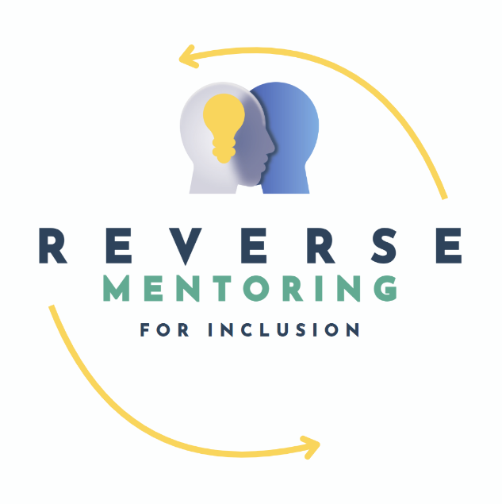

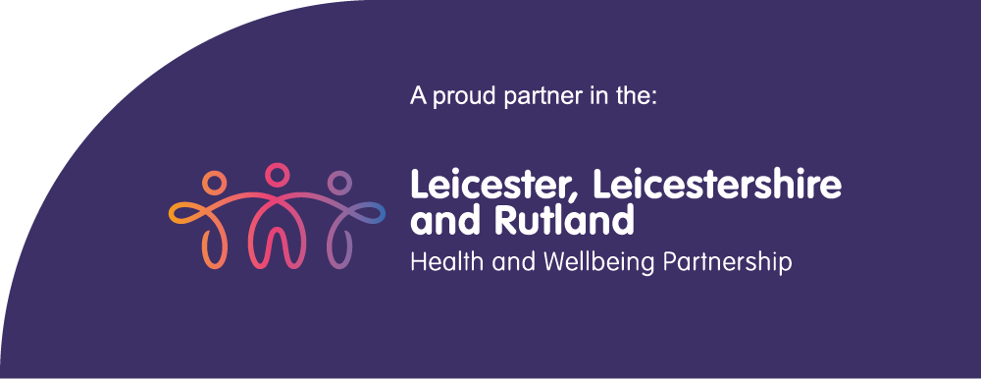

Reverse Mentoring For Inclusion Programme

Applicant Information Pack

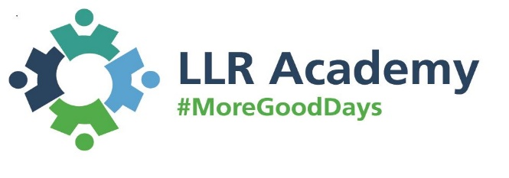

Contents:

1. About the programme

2. The application process and guidance

3. Commitment to the programme and beyond

4. Programme schedule
- Reverse Mentoring for Inclusion – about the programme
The Leicester, Leicestershire, and Rutland (LLR) Integrated Care System are proud to launch our Award winning Reverse Mentoring for Inclusion Programme’s 7th Cohort for 2026. For the first time, the Programme has been expanded to include Northamptonshire NHS colleagues. All healthcare colleagues across LLR and Northamptonshire are welcome to apply, as well as social care, Local Authority and VCSE colleagues from LLR (we hope to expand the programme to include social care colleagues from Northamptonshire in later cohorts).

Reverse mentors or mentees will be trained and be “matched” and enter a reverse mentoring relationship which aims to improve understanding and empathy. Typically, the Mentor will be more junior and the Mentee more senior, with the Mentor shared their lived experience and personal knowledge of race, religion, disability, sexuality, and/or gender. However, everyone is eligible to apply and it may be that you are matched with someone of a similar seniority.

The 2026 Cohort 7 programme sets out to address race, religion, disability, LGBTQ+ and gender topics building on the success of our previous programmes.

- What is reverse mentoring for Inclusion?

Reverse Mentoring for Inclusion turns traditional mentoring on its head. The Mentor is a more junior colleague who mentors a more senior colleague. The Mentor has lived experience of race/ethnicity, religion, disability, LGBTQ+, and/or gender to share with their Mentee. Preconceptions can be challenged as well as tackling unconscious bias. The result is more informed, empathetic, compassionate leaders who make a difference to their colleagues and communities. Reverse Mentors in turn get the opportunity to share their lived experience, network with leadership and make an impact to creating inclusive cultures. They will provide an insight into the difficulties and barriers they may have faced, with opportunities to explore how the more senior colleague could learn from and adapt their future leadership approach to ensure they are more inclusive and appreciative of the diversity of their workforce and communities. It gives a great opportunity for everyone to increase their cultural and inclusive competencies that lead to better health and wellbeing outcomes for everyone.
You will meet with your mentor/mentee 6 times across 6 months (or more if you would both like to). We encourage you to meet in person where possible, although many pairs have had successful meetings via Teams as well. This can include:
- Sharing experiences
- Visiting locations related to the Mentor’s cultural background – e.g. a religious place
- Shadowing the Mentee at meetings and providing constructive feedback on how inclusive they were.

- Who is it for?

We are looking for a good cross section of colleagues willing to be either Reverse mentors or mentees. Reverse mentors for inclusion would ordinarily be junior members of staff, however the mentee could be any member of staff wishing to be reverse mentored. This programme is about sharing lived experience through the diversity lens. Anyone is therefore welcome to apply.
A Reverse Mentor must be eager to support colleagues from across the health and social care system. You must be able to help the reverse mentee discover their strengths and weaknesses in order to focus them on their own personal development specifically linked to inclusion.
As a Mentee you must be committed to the principles of reverse mentoring. Be willing to listen and understand the role of the reverse mentor.
In order to be accepted onto the programme you will need to meet the person specification and be prepared to become an active Reverse Mentor or Mentee for 2026.

Reverse Mentor Person Specification
All of the following:
- Be from an ethnic or cultural minority background, have a disability, be part of the LGBTQ+ community and/or want to speak about gender issues
- Commit to attending the training provided (3 hours)
- Be willing to ensure that the principles of reverse mentoring are applied.
- Ensure that all meetings between the reverse mentor and mentee are attended (6 meetings, one hour in duration for each meeting over 6 months)

Reverse Mentee Person Specification
- Anyone wishing to be mentored on inclusion from someone who has a different lived experience to them in respect of race, disability, gender and/or or LGBTQ+
- May be from a Leadership role (for example, team leader, manager, Head of Service, Director, Chief Executive)
- Commit to all meetings with their reverse mentor (6 meetings, one hour in duration for each meeting over 6 months)
- Attend all the training (1 hour), and evaluation session at the end of the programme (1.5 hours)

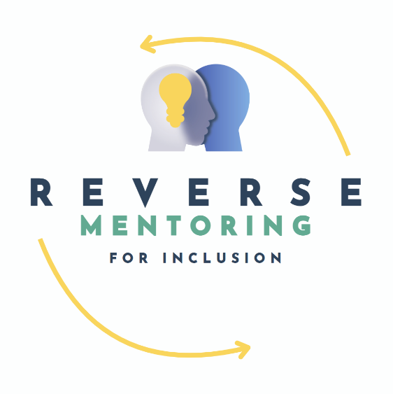

- The application process and guidance

First, agree with your line manager that you can be released for the dates below (for mentors, or mentees, as applicable – please note the mentors’ peer support sessions are optional).
Then, fill in the application form and submit. We will contact you to confirm enrolment and provide further information about training dates. To apply please use the link below:
Click here for the Reverse Mentoring Application Form.
If you require support with form filling, please contact lpt.edi@nhs.net or llr.academy@nhs.net.
Previous participants do not need to reapply if your details have not changed; email: lpt.edi@nhs.net to let us know you want to be included in this cohort.

Deadline for applications is Thursday 12th March 2026.

- Commitment to the programme and beyond

We will provide the following to support you in your role as a Reverse Mentor or Mentee:

- Training
- On-going support from your Equality Teams/HR or OD Teams as appropriate
- Evaluation and feedback from the programme

4. Programme Schedule (may be subject to change – final dates will be shared with successful applicants)

Reverse Mentoring For Inclusion Training Dates For Mentees (only one of these needs to be attended)
Friday | 27th March | 11.00 - 12.00
Tuesday | 14th April | 13.00 - 14.00

Reverse Mentoring For Inclusion Training Dates For Mentors (only one of these needs to be attended)
Thursday | 26th March | 9.30 - 12.30
Monday | 13th April | 13.00 - 16.00

Midway Reflections for Mentees dates (only one of these needs to be attended):
Wednesday | 29th July | 9.00 - 10.00
Thursday | 30th July | 14.00 - 15.00

Evaluation Session For Mentees (only one of these needs to be attended)
Monday | 30th November | 14.00 - 15.30
Monday | 14th December | 14.00 - 15.30

Peer Support Meeting Dates Schedule for Mentors (these are optional):

Tuesday | 23rd June | 10.00 - 11.30
Thursday | 23rd July | 10.00 - 11.30
Thursday | 20th August | 10.00 - 11.30
Monday | 21st September | 13.00 - 11.30
Friday | 16th October | 14.30 - 16.00
Wednesday | 18th November | 14.00 - 15.30

Plus a celebration event at the end of the programme, date tbc.

