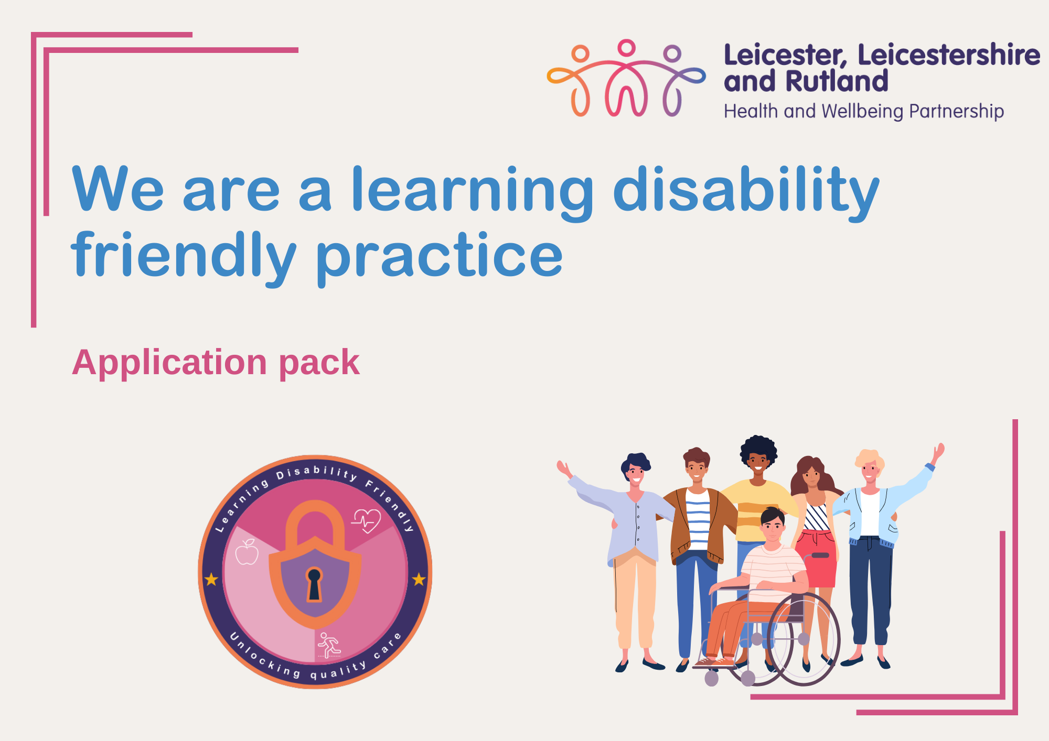

Learning Disability (LD) Friendly Practice Award
Accreditation
Accreditation of the award the follows a simple process:
• GP Practices apply and provide the required evidence that they meet the standard
• A panel of health professionals and people with lived experience will review applications and approve the award level, they will provide feedback as to why the level of award was awarded and what practices can do to reach the next level
• A register of LD Friendly Practices is maintained by LLR Health Equity Team

Application Process

Practices may apply to the scheme at any time and may re-apply if an initial application is unsuccessful in achieving the award for which they were aiming. The panel will provide constructive feedback on why the application was unsuccessful to support a subsequent application within one month. Practices with the award will be maintained by the Health Equity Lead, practice status will be reviewed and updated as each practice submits a new application.
The LD Friendly Practice Award can be withdrawn if there is clear evidence that a requirement is no longer being met.
The LDHC Network Panel reviewing applications will be made up of active network members and will include as a minimum:
- Transformation Clinical Lead Learning Disabilities Leicester Leicestershire and Rutland ICB
- The Health Equity Lead or deputy
- Primary Care Liaison Nurse
- An ICB representative
- Someone with lived experience

Award standards application

Practice: | Name of person/people filling out form:
Date sent for panel approval:

Criteria | Bronze | Silver | Gold | Evidence – please delete pre-evidence guidance
Staff training in learning disability awareness | ☐  The practice is aware of learning disability training that can be accessed. | ☐  The Lead GP and admin who are involved in the delivery of health checks, attend annual Learning Disability awareness training, and have completed both parts (e-learning AND live session) of the Oliver McGowan mandatory training at Tier 2 level. | ☐  In addition to silver level, all practice staff have completed both parts (e-learning AND live session) of the Oliver McGowan mandatory training at either Tier 1 or Tier 2 level.  ☐  The practice access yearly update training from the PCLN team. | E.g.  - Details of staff attendance at Oliver McGowan Training  - Annual learning disability training provided by PCLN  - Training attended with dates  - Other relevant training completed
Named Leads for LD Link staff | ☐  The Practice has a named Lead GP for Learning Disability. | ☐  The Practice has a named Lead GP AND a nominated Administrator for Learning Disability | ☐  The Practice has named Lead GP AND Nurse AND Administrator for Learning Disabilities. | Please state the names of nominated staff.  - GP  - Nurse  - Administrator
Learning Disability Ambassador | ☐  The practice is aware of the GP LD Ambassador scheme | ☐  The practice has a nominated LD Ambassador in the practice | ☐  The practice has AN Ambassador within the practice and shows evidence of how network shared information is disseminated within their practice | Please tell us if anyone/who attends the ambassador meetings. (You can sign up via your PCLN)  - Regular agenda items on PLT etc
LD Register | ☐  All patients with a learning disability are identified, coded and on a learning disability register.  ☐  It is more than 12 months since Learning Disability register was validated by a PCLN within the past 12 months, BUT plans are in place to complete this in this current year. | ☐  As Bronze, PLUS the LD Register has been reviewed internally by named lead GP OR Nurse OR Administrator for learning disabilities, to remove persons not eligible to be included. | ☐  As Silver, PLUS the LD Register has been independently validated within the last 12 months by a Primary Care Liaison Nurse (PCLN). | E.g.  - Number of people on LD Register  - Date reviewed internally.  - Date most recently validated by PCLN and name of PCLN  - Date register validated.  Additional plans with PCLN nurse i.e. register validated as new people identified and added.
Achievement of high-quality LD Annual Health Checks (AHC) | ☐  The Practice is signed up to the learning disability AHC DES. | ☐  The Practice achieved the national target of 75% or above of AHCs completed in the previous year.  ☐  All eligible patients from the LD register are invited to an AHC | ☐  The Practice achieved the national target of 75% or above of AHCs completed in the previous year, AND a high-quality Health Action Plan (HAP) was shared with each person.  ☐  As Silver PLUS all materials relating to AHC are provided in the accessible format of the person’s choice. The invitation includes a copy of the ‘Easy Read Guide to Annual Health Checks.’ | E.g.  - % of AHCs completed last year  - Plans for achievement in current year  - Detail of prioritisation of those that haven’t accessed a health check in past two years, or people with co-morbidities.  - Anonymised example of a completed high-quality HAP  - What reasonable adjustments are used to invite people for their health check.  - Attach examples of easy read invites used.
Annual Health Checks - Appointment | ☐  Health check appointments are at least 30 mins long. | ☐  As Bronze, PLUS the person is seen face to face for the physical element of the health check. | ☐  As Silver, PLUS Both elements of the health check are completed face to face, with the person using their identified reasonable adjustments. | E.g.  - Please expand
Annual Health Checks - Template | ☐  All health checks are carried out using an accredited template. | ☐  Health checks are carried out using the LLR locally validated template. | ☐  As Silver. | E.g.  Please specify which template you are using to complete the annual health check
Health Action Plan (HAP) | ☐  Following the AHC, a HAP is completed and provided to the patient with all actions captured. | ☐  As Bronze, PLUS Following an annual health check a printed copy of the patients HAP is given. | ☐  Following the AHC a personalised HAP is printed and given to the patient or their carer.  ☐  The practice follows up on all onward referrals made post AHC. | E.g.  - Anonymised easy read/accessible health action plan
Screening | ☐  People with learning disabilities and/or autism are actively encouraged to participate in screening programmes. | ☐  As Bronze, PLUS  The Practice advises on cancer screenings and signpost to local specialist clinics that may be more accessible or appropriate. | ☐  As Silver, PLUS  The practice offers reasonable adjustments to support people with learning disabilities to access screening within their practice and engages with the PCLN team where someone requires additional support. | E.g.  - Use of accessible information used with patients i.e. cervical screening DVD
Mental Capacity Act | ☐  The person completing the annual health check/or health appointment has had education around the appropriate use of the Mental Capacity Act (2005). | ☐  As Bronze, PLUS and the person is able to demonstrate the ability to apply the principles of the Mental Capacity Act (2005) | ☐  As Silver PLUS The practitioner considers capacity throughout the appointment/assessment and is able assess capacity, and determine best interests for an individual who lacks capacity to make  a specific decision. | E.g.  - Dates and details of MCA training attended  - Examples of use of MCA to support someone to access health treatments
Was not Brought Safeguards | ☐  Codes relating to “was not brought”, “declined” and “did not attend” are used. | ☐  Codes relating to “was not brought”, “declined” and “did not attend” are used appropriately and are followed up. | ☐  Reasonable adjustments are flagged/alerted and routinely offered to ensure they are available for all appointments. | E.g.  - What is the practice’s ‘not brought’ policy  - Examples of where it has been used and outcomes
Reasonable adjustments | ☐  Reasonable adjustments are identified for LD patients. For example – extended appointment times offered, and communication provided in their preferred format.  ☒  The practice is aware of the different tools that can be used to support someone i.e. hospital passport, DisDat tool, communication passport. | ☐  As Bronze, PLUS Reasonable adjustments are identified and placed on the clinical record in line with the NHS Reasonable Adjustment Digital Flag.  ☐  Longer appointments for patient with Learning Disabilities are offered routinely.  ☐  the practice promotes the use of the Hospital Passport DisDat tool, communication passport. | ☐  As Silver PLUS An information pack about the practice is available if required by someone including for example - photos of the practice/waiting room and staff to help people prepare for an appointment  ☐  The practice has a usable and accessible GP website for patients  ☐  the practice actively supports someone to access the different tools that can be used to support someone i.e. hospital passport, DisDat tool, communication passport, and records that the person has one on the persons Reasonable Adjustment Digital Flag. | E.g.  - information pack about the practice is available if required by someone, showing photos of the practice/waiting room and staff to help people prepare for an appointment?  - Examples of GP grab sheets if used.
LeDeR | ☐  The practice notifies all deaths of individuals with learning disabilities and autistic people (aged 18 and above for autistic people) to the LeDeR programme. | ☐  As Bronze, Plus the surgery engages with the LeDeR programme regarding those deaths. | ☐  As Silver, Plus, the surgery is aware of local LeDeR reports, governance panels and acts upon the feedback, demonstrating this informs positive change. | E.g.  - Please explain how the practice is using the LeDeR National report, local LeDeR report and LeDeR feedback to influence change in the practice i.e. regular agenda item on minutes etc.  - Changes made in response if any  - Sending required records when requested and/or discussion with LeDeR reviewer.
Weight/BMI | ☐  A patient’s weight is discussed as part of the AHC | ☐  A patient’s weight is recorded at the health check or within three months of the health check being completed AND the advice given is documented on their health action plan which a copy is given to the person. | ☐  As Silver PLUS Any patient whose weight is outside a healthy BMI has a clear plan to follow including identification of risks.  ☐  Any patient who is wheelchair dependant and has a BMI outside of healthy range is supported to access accessible weighing scales and a clear plan is in place to support them to reach a healthy BMI. | E.g.  - Share how the accessible weighing scales have been used.  - Onward referrals to dietetics, healthy eating/weight programmes, social prescribers’ involvement etc  - Evidence of where the Nutrition and Hydration resource has been shared with patients/carers and families (due to be launched 2025)
Blood taking | ☐  The practice is aware that an annual blood test is recommended for all patients who offered an annual health check | ☐  As Bronze, PLUS the practice routinely offers blood tests as part of the patient’s annual health check | ☐  As Silver PLUS the practice  ☐  Where a patient requires additional support and, there is clinical evidence, the person requires a blood test. There is evidence the practice engages with the CLDT/PCLN/ team for support. | E.g  - Examples of where reasonable adjustments have been used to support someone to have a blood test.  - Use of enhanced hours to create a safe space to host a specialist venepuncture clinic.  - Evidence of MDT working.
Sensory Environments | ☐  The Practice is aware of its accessibility requirements under the Equality act. | ☐  As Bronze, PLUS the practice is aware of the sensory environment checklist and has plans/intends to engage in the programme. | ☐  A review of the practice environment has been conducted by people with lived experience to ensure it is comfortable and accessible, e.g., disabled parking, quiet zone, accessible toilet etc. | E,g  - Invite patients from your learning disability register to come and support competing the friendly environment checklist.  - Use opportunities e.g., health promotion days, health check clinics to ask people to give feedback whilst at the practice.  - what was the advice given by people with lived experience when they completed the accessibility check at your practice?
Sensory Equipment | ☐  The practice is aware of the importance that sensory equipment can play in fostering a supportive environment to enable someone to access health appointments. | ☐  The practice advertises that they offer sensory support in the practice including the use of the sensory equipment/pack that is available for patients who may require the use of it. | ☐  As Silver PLUS, the practice routinely offers the use of a sensory bag to people with learning disabilities and autistic people without the patients/carers having to ask for one. | E.g  - Indicate how you inform people that there is the use of sensory equipment.  - Examples of how the sensory bag has been used.  - If the practice is not in receipt of a sensory bag please liaise with your PCLN to receive one.
Stomp/Stamp | ☐  People with a learning disability are invited to have regular medication reviews | ☐  The principles of STOMP/STAMP are considered when reviewing a pt with Learning Disabilities.  ☐  Medication information is given in a format that is accessible to the person; for example, easy read, video or plain English  ☐  The surgery is aware of the direct support line for Stomp/stamp Lpt.ldstomp@nhs.net  Lpt.camhs-stomp.stamp@nhs.net | ☐  As part of any review, practitioners consider and offer alternatives to medication where appropriate, such as sleep hygiene or other non-pharmacological support.  ☐  People, families and support staff in decisions about medication
End of Life Care | ☐  The practice is aware of accessible information around end-of-life care including Easy Read Advanced care planning | ☐  As Bronze, PLUS the practice discusses End of life care/planning as part of someone’s annual health check and any discussions/decisions are recorded on their health action plan if appropriate. | ☐  The practice supports people to engage in Advance Care Planning (ACP) (ensuring mental capacity is  considered).  ☐  Details about a person’s end of life care preferences (including the ACP) are added to the person’s electronic care records.  Ensuring decisions are  • documented  • regularly reviewed  • communicated to key persons involved in their care. | Top Tip.  •Start the conversation as early as possible. Conversations should be ongoing.  Good practice example:  ‘Victoria’s plan was written from both the wishes of the family and a ‘best interests’ medical decision. Victoria no longer had the capacity to make any decisions about her care. This plan was written by the team and it enabled joint action to take place at every stage. It became a very useful resource, guide and comfort’.  Jean Willson, OBE, talking about her daughter’s end of life care  - Examples of anonymised easy read advanced care plan
Patient Engagement | ☐  The practice has a mechanism in place for patients and/or their family or carers to provide feedback on their experiences at the practice. | ☐  People with Learning disabilities and/or autism are encouraged to give feedback of their experiences at the practice | ☐  People with a learning disability and autistic people are encouraged to be involved in Patient Participation Groups.  ☐  Feedback forms are published in an accessible format to enable people who require accessible information can give feedback.  ☐  Feedback from friends and family tests are published in an accessible format to enable people who require accessible information to read and understand it. | E.g.  •examples of accessible information minutes of meetings
Is there anything else you would like to tell us about in relation to how you support people with learning disabilities in your practice?

Thank you for completing the above application form, please now email the form and all supporting information to Rebecca Eccles – Health Equity Lead, LDA Collaborative. rebecca.eccles@nhs.net

With thanks to:
- NHS Lincolnshire Integrated Care Board
- NHS Coventry & Warwickshire Integrated Care Board

- Insight training

